Session 6(5-3): Two-dimensional Object Reflection

Intended Learning Outcome:

- Students will be able to adopt the movement control of object in the display.

- Students will be able to better understand about axis (X, Y) wise movement and controlling.

Expected Skills:

- Better Understanding about axis (X,Y)

- Clear idea about polygon drawing with any variable

Tools Required:

- CodeBlocks

- OpenGL and GLUT using CodeBlocks.

Session Detail:

Object reflection in different axis:

#include <GL/glut.h>
#include <stdio.h>
#include <GL/gl.h>
// Original triangle coordinates
float x1 = 50, y1 = 50;
float x2 = 150, y2 = 50;
float x3 = 100, y3 = 150;

// Reflected coordinates
float rx1, ry1, rx2, ry2, rx3, ry3;

int choice;

void init(void)
{
glClearColor(0.0,0.0,0.0,0.0); //GLfloat red,green,blue,alpha initial value 0 alpha values used by glclear to clear the color buffers
glMatrixMode(GL_PROJECTION); // To specify which matrix is the current matrix & projection applies subsequent matrix to projecton matrix stack
glLoadIdentity();
glOrtho(-400.0, 400.0, -400.0, 400.0, -1.0, 1.0);
//gluOrtho2D(0.0,300.0,0.0,300.0); // Orthographic representation; multiply the current matrix by an orthographic matrix 2D= left right,bottom,top equivalent near=-1,far=1
}

void Draw()
{
glClear(GL_COLOR_BUFFER_BIT);

// Draw Original Triangle (Blue)
glColor3f(0.0, 0.0, 1.0);
glBegin(GL_TRIANGLES);
glVertex2f(x1, y1);
glVertex2f(x2, y2);
glVertex2f(x3, y3);
glEnd();

// Draw Reflected Triangle (Red)
glColor3f(1.0, 0.0, 0.0);
glBegin(GL_TRIANGLES);
glVertex2f(rx1, ry1);
glVertex2f(rx2, ry2);
glVertex2f(rx3, ry3);
glEnd();

glutSwapBuffers();

}

int main(int argc,char **argv){
printf("Choose Reflection Type:\n");
printf("1. Reflection about X-axis\n");
printf("2. Reflection about Y-axis\n");
printf("3. Reflection about Diagonal (Origin)\n");
printf("Enter your choice: ");
scanf("%d", &choice);

if(choice == 1)
{
// Reflection about X-axis (x, y) -> (x, -y)
rx1 = x1; ry1 = -y1;
rx2 = x2; ry2 = -y2;
rx3 = x3; ry3 = -y3;
}
else if(choice == 2)
{
// Reflection about Y-axis (x, y) -> (-x, y)
rx1 = -x1; ry1 = y1;
rx2 = -x2; ry2 = y2;
rx3 = -x3; ry3 = y3;
}
else if(choice == 3)
{
// Reflection about diagonal / origin (x, y) -> (-x, -y)
rx1 = -x1; ry1 = -y1;
rx2 = -x2; ry2 = -y2;
rx3 = -x3; ry3 = -y3;
}
else
{
printf("Invalid choice!");
return 0;
}
glutInit(&argc,argv);
glutInitDisplayMode ( GLUT_RGB | GLUT_DOUBLE );
glutInitWindowPosition(0,0);
glutInitWindowSize(500,500);
glutCreateWindow("Lab Final");
init();
glutDisplayFunc(Draw);
glutMainLoop();
return 0;
}

Output:
Choice 1 | Choice 2 | Choice 3
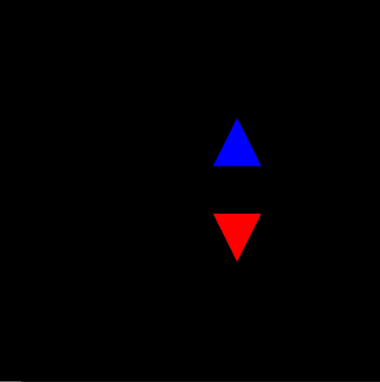 |  | 